BRACE LINE ORTHODONTICS

**2019**

Administrator

SAI ORTHODONTIC SPECIALITY CLINICS LLP

2019

The most obvious goal of orthodontic treatment is creating beautiful faces, giving healthy teeth and attractive smiles

Brief Introduction

The very concept of specialty orthodontic clinics is a first of its kind in India. This unique concept is a brain child of three orthodontist with vast clinical experience in this field. The reason we came out with this concept was the day to day difficulty and challenges faced by patients, general dentist and orthodontist in traditional system of visting orthodontic practice. In this old traditional system orthodontists visit a particular dental clinic once in a month for treating orthodontic patients which makes his availability very limited. As orthodontics is a super specialty branch which involves rigorous training for 3 complete years(M.D.S) which involves preclinical and clinical works under the guidance of senior professors round the clock after completing graduation(B.D.S), the general dentist with a graduation degree has a very minimal skills to handle orthodontic patients for which he takes the services of an orthodontist. Due to the limited time given by orthodontist for a particular clinic its becoming very difficult for the general dentist to give this specialty treatment in there clinics. Any complications a patient faces in between the visits of the orthodontist the general dentist needs to handle them for which his skills are limited there after the patient being the sufferer. Also in recent times the general dentist are undergoing training in unauthorized academies spread across india to learn orthodontics in just few weeks of time thus giving sub standard knowledge and unauthorized degrees which in turn harms the patients. Also there is lack of awareness in people regarding orthodontics as a specialty branch and a patient needs to visit orthodontist but not general dentist for his/her treatment needs.

Considering the all above factors we have come out with this unique concept which provides 100% genuine treatment to all the patients under the tag BRACELIE ORTHODONTIC CLINICS.

We will be offering complete range of orthodontic treatments with specialists round the clock available with all our branches with high experience and success.

Orthodontics

Dentistry is a very diverse branch of medicine that is constantly in flux as a science, and which again and again makes high demands on the practitioners. It is important to be constantly updated and to be up-to-date in order to offer patients the best possible form of therapy. Orthodontics/orthodontics is a specialty of dentistry, which deals with malpositions in the mouth, - BONE - and facial area and its success also have a direct impact on the psyche of humans. It is always a nice experience to see how the teeth straighten themselves during the orthodontic treatment and the patients gain a new self-confidence. They feel better in their social environment again.

Orthodontics is the specialized branch of dentistry concerned with variations in dentofacial traits that may affect an individual’s overall well-being. A dentofacial trait is defined as a hard (teeth and jaws) or soft (gums and face) tissue characteristic or combination of characteristics that distinguishes an individual’s facial appearance and determines his or her level of oral and social function.  
  
Orthodontic treatments include therapies that enhance a dentofacial trait or traits, thus improving a person’s level of health and wellness. You may choose to consult with an orthodontist after receiving a referral from your child’s pediatric or general dentist

Market scope

**The Global Orthodontics Market** was valued at $1,493 million in 2016, and is estimated to reach at $2,597 million by 2023, registering a CAGR of 8.2% from 2017 to 2023.

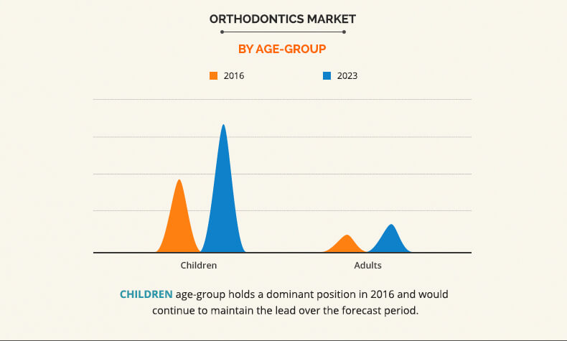

Increase in aging population and surge in prevalence of dental diseases boost the growth of the global orthodontics market. Furthermore, rise in awareness towards oral hygiene & dental aesthetics and surge in dental tourism drive the market growth.

High demand for improving aesthetic appearance and surge in awareness about orthodontics supplies are expected to propel the market growth.

India with **1.21 billion people** constitutes as the second most populous country in the world, while children represents 39% of total population of the country. The figures show that the larger number of about 29 percent constitutes Children below 10 years. This itself shows how good the scope for orthodontics in India.

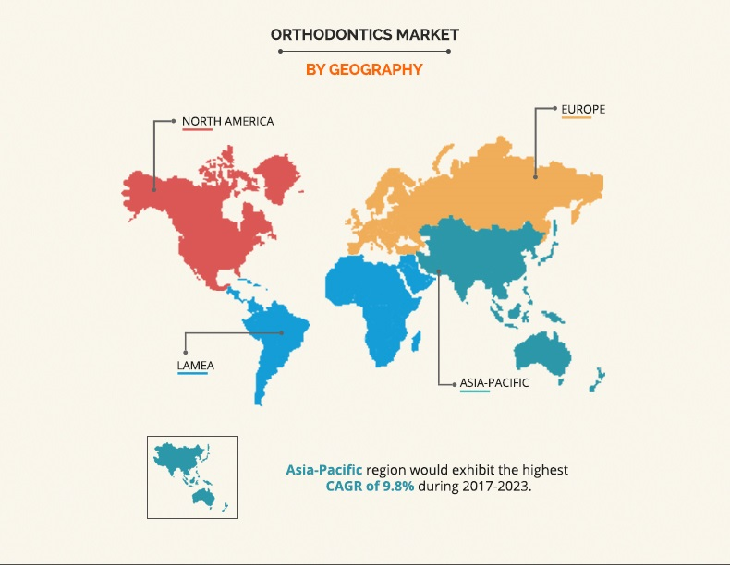

FINANCIALS - BRIEF

FOR SIX BRANCHES

BRANCH 1 : HIMAYATNAGAR

BRANCH 2 : KARKHANA ROAD, SECUNDERABAD

BRANCH 3 : GACHIBOWLI

BRANCH 4: CHANDA NAGAR

BRANCH 5 : KUKATPALLY

BRANCH 6 : DILSUKH NAGAR

* PROJECT ESTABLISHMENT COST – RS 2,32,00,000
* OPERATIONAL COST FOR 9 MONTHS = 3,07,00000
* TOTAL PROJECT COST
* ESTABLISHMENT COST + OPERATIONAL COST(9 MONTHS) = 5,39,00,000

RETURN OF INVESTMENT – 1ST YEAR

* OPERATIONAL COST FOR IST YEAR FOR 6 BRANCHES – 4,27,68,000
* TOAL REVENUE FOR 6 BRANCHES FOR 1YEAR OF OPERATION = 3,60,00,000
* IST YEAR DEFICIT = 67,68,000

RETURN OF INVESTMENT – 2ND YEAR

* OPERATIONAL COST FOR 2ND YEAR FOR 6 BRANCHES - 5,79,72,000
* TOAL REVENUE FOR 6 BRANCHES FOR 2ND YEAR OF OPERATION - 600,00,000
* 2ND YEAR PROFIT (BREAKEBVEN) - 20,28,000

FINANCIALS – DETAILED

1. Establishment cost per branch

|  |  |
| --- | --- |
| Building advance | 4,00,000 |
| Interiors | 16,00,000 |
| Equipment cost | 10,00,000 |
| Additional equipment (OPG AND LAT CEPH) | 5,00,000 |
| Mobile Dental Van | 2,50,000 |
| Software | 40,000 |
| Paper less clinic | 75,000 |
| Total | 38,65,000 |
| FOR 6 BRANCHES | 2,32,00,000 |

1. DETAILS OF STAFF WITH SALARIES PER BRANCH

|  |  |  |  |  |
| --- | --- | --- | --- | --- |
| Designation | Qualification | No of post | Salary per month | total |
| Orthodontist | M.D.S | 1 | 35,000 Basic | 35,000 |
| Duty Doctor | B.D.S | 1 | 20,000 | 20,000 |
| Chair side assistant | Intermediate/graduate | 2 | 10,000 | 20,000 |
| Receptionist | Graduate | 1 | 15,000 | 15,000 |
| Marketing executive | M.B.A Marketing | 1 | 30,000 | 30,000 |
| Visiting senior consultant | M.D.S | 1 | 4000/DAY | 32,000/8DAYS |
| TOTAL | | | | 1,52,000 |

TOTAL SALARIES PER BRANCH PER MONTH – 1,52,000

1. OPERATIONAL COST PER BRANCH PER MONTH

|  |  |
| --- | --- |
| Building rent and maintainance | 70000 |
| Electrictity bill | 15000 |
| Dental Consumables | 20000 |
| Non dental consumables | 5000 |
| Marketing and advertisement | 60000 |
| Administration cost | 25000 |
| Miscellaneous | 12000 |
| Equipment maintainance cost | 10000 |
| Total | 217000 |

TOTAL OPERATIONAL COST PER BRANCH PER MONTH – 217000

1. DIRECTORS SALARY PER MONTH 25000

TOTAL FOR 4 DIRECTORS = 4 X 25000 = 1,00,000

1. BANK EMI @ 11% FOR 4,00,00,000 = 600000/MONTH

TOTAL OPERATIONAL COST PER MONTH B+C+D excluding EMI = 469000/ MONTH

FOR 6 BRANCHES WITH EMI = 2814000 + 600000 = 3414000

Operational cost for 9 months = 3,07,00000

TOTAL PROJECT COST

ESTABLISHMENT COST + OPERATIONAL COST(9 MONTHS) = 5,39,00,000

ROI

PROJECTION FOR 1ST Year

No of cases per branch

|  |  |  |  |
| --- | --- | --- | --- |
| Type | Number of cases | Cost | Total |
| Metal braces | 140 | 30000 | 4200000 |
| Ceramic braces | 20 | 40000 | 800000 |
| Self ligating | 5 | 70000 | 350000 |
| Aligners | 5 | 100000 | 500000 |
| Orthodontic implants | 50 | 5000 | 250000 |
| General dentistry | | | 1200000 |
| TOTAL | | | 73,00,000 |
| EXPECTED COLLECTION | | | 6000000 |

TOAL REVENUE FOR 6 BRANCHES FOR 1YEAR OF OPERATION = 6 X 60,00,000 = 3,60,00,000

IST YEAR BALANCE SHEET

OPERATIONAL COST FOR IST YEAR FOR 6 BRANCHES = 4,09,68,000

Doctors incentive = 18,00,000 @ 5%

IST YEAR DEFICIT = 67,68,000

PROJECTION FOR 2ND YEAR

|  |  |  |  |
| --- | --- | --- | --- |
| Type | Number of cases | Cost | Total |
| Metal braces | 160 | 30000 | 48,00,000 |
| Ceramic braces | 25 | 40000 | 10,00,000 |
| Self ligating | 10 | 70000 | 7,00,000 |
| Aligners | 10 | 100000 | 10,00,000 |
| Orthodontic implants | 75 | 5000 | 3,75,000 |
| General dentistry | | | 30,00,000 |
| 1ST YEAR CARRY FORWARD COLLECTION | | | 13,00,000 |
| Total | | | 1,21,75,000 |
| Expected collections | | | 100,00,000 |

TOAL REVENUE FOR 6 BRANCHES FOR 2nd YEAR OF OPERATION 6 x 100,00,000 = 600,00,000

2nd YEAR BALANCE SHEET

OPERATIONAL COST FOR 2nd YEAR = 1st year + 12% = 458,84,000

Doctor incentive = 30,00,000

Depricition = 23,20,000

Last year deficit = 67,68,000

Total expenditure at second year = 5,79,72,000

Total profit 2nd year = 20,28,000